# ECOMMENRCE WEBSITE

**1. INTRODUCTION:**

Now a days the life style of the people is different. People feel uncomfortable and time consuming for going crowded markets. So, Online Store is a boon as it saves lots of time. Online shopping is a process whereby consumers directly buy goods, services etc. from a seller without an intermediary service over the internet. Shopper can visit webstores from the comfort of their house and shop as by sitting in front of the computer.

**2. DESIGN AND IMPLEMENTATION:**

Frontend is what appears on the user’s side most and what entices the users to give the website a stroll. Hence, the designers work at the base level of this process. The UI designer and UX engineer both works collaboratively to make the website appear at its best with less delay and amazing easy to navigate functionalities.

However, below is a summary of some of the mostly using Front-end Technologies which our developers have expertise in:

1. HTML
2. CSS
3. BOOTSTRAP
4. JAVASCRIPT

I have implemented using basics of html css JavaScript and bootstrap as well on carousel and many more. The click actions also performs many stuff.

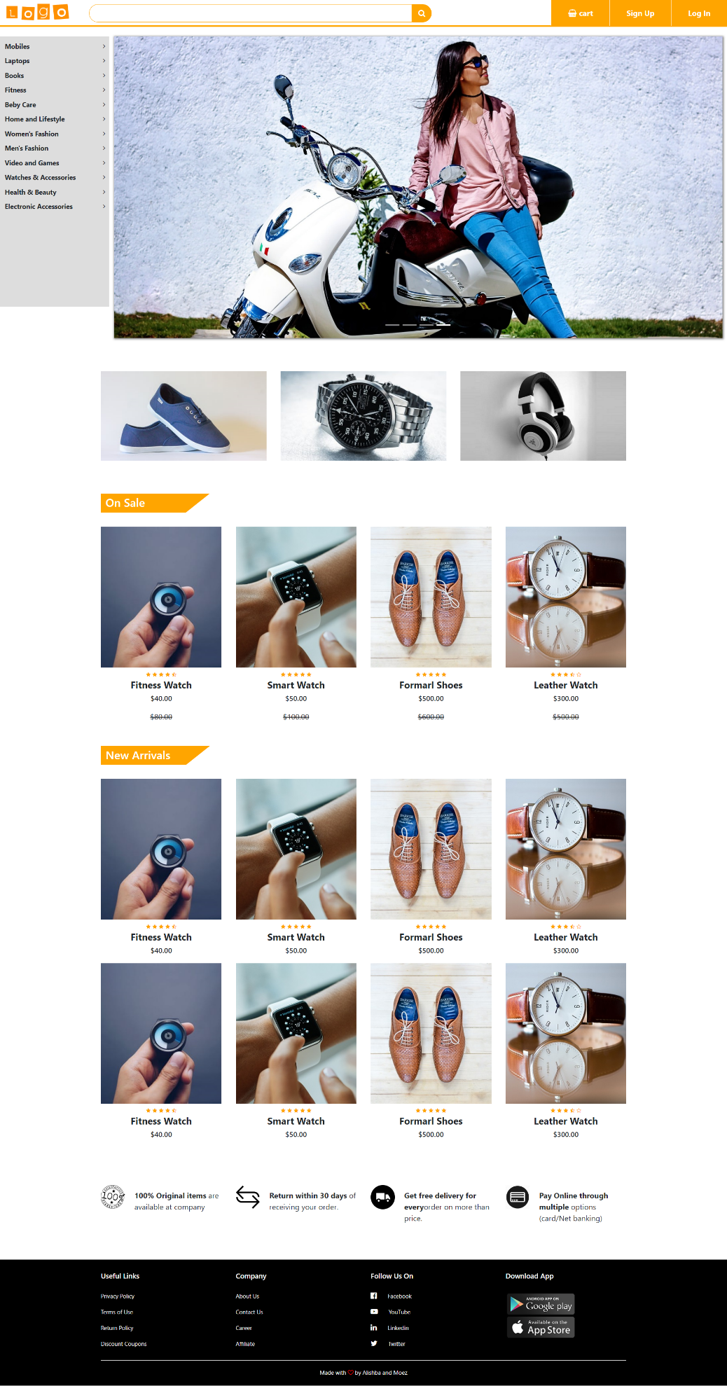

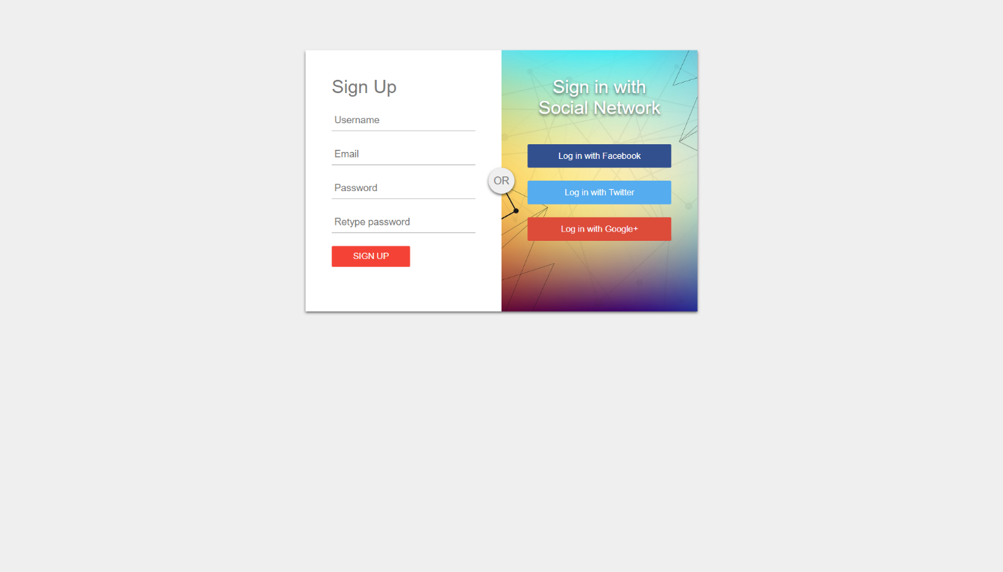

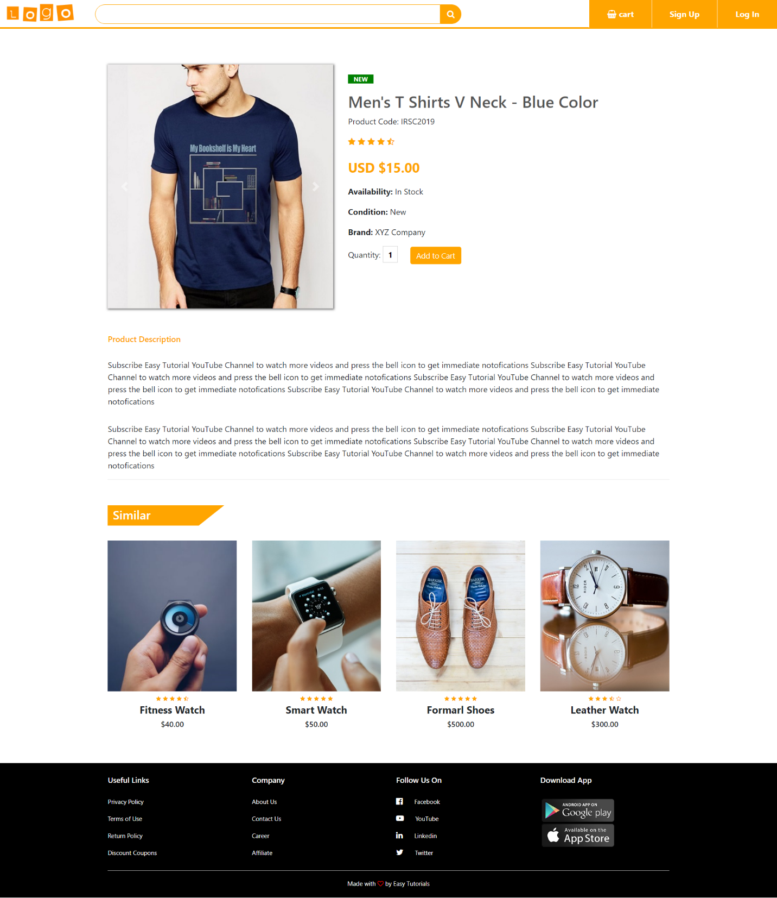

**3. CONCLUSION**

This website make it easy for people to order new stuff from home even though it also saves a lot of time that people usually wastes in market. Saves energy as well.